Seizing the White Space
10 February 2011
21:22
1 White Space and Business Innovation
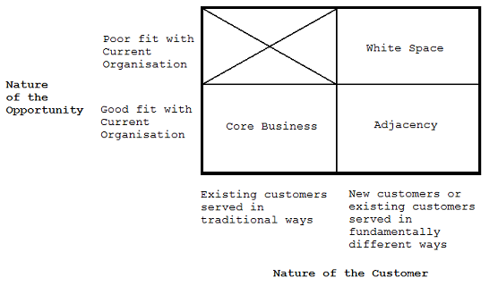

2 Business Model Framework
Consists of five major elements
- Customer Value Proposition
- Profit Formula
  - Revenue Model
  - Cost Model
    - Target Unit Margin - Operating Profit per Unit required to achieve desired profit level
  - Resource Velocity / Inventory Turns
Core Competences
- Key Processes
- Key Resources
- Target Market

Rules norms and metrics help to tie the model together. These tend to be formed last but once formed can provide the driving force behind the model.

3 Shifts in Basis of Competition
As a product moves through its life cycle unique selling points need to change
- Product Innovation  - Process Innovation  - Business Model Innovation  - Business Model Innovation | Features and Performance  Quality and Reliability  Convenience  Cost [Now a commodity]

4 Creating New Markets
Inhibitors to potential clients produce market barriers (WASTe)
- Wealth - too costly
- Access - provide the supply chain
- Skills - (usability) provide solution that is accessible to the layman
- Time - too time consuming

Democratizing products brings them to a larger market.
The Hindustan Unilever Shakti Initiative used local community to produce local sales representatives.

Problem-Solving Continuum
A predictable pattern by which the way people solve problems shifts over time as they gain more knowledge. When knowledge is low, people must make do with unstructured attempts to solve a problem. As they gain more knowledge, they begin to recognize patterns and eventually to devise reliable rules to guide their problem-solving efforts. As knowledge in an industry moves along the problem-solving continuum, opportunities in a company’s white space open up, allowing it to develop new customer value propositions and new business models that democratize products and services by overcoming barriers to consumption.

5 Discontinuity and Disruptive Changes
These are ideal for changing business models, often requiring adaptation to remain in business.

Potential drivers (GWEnT)
- Government and Politics
- World Current Affairs
- Environment
- Technology

6 Designing a New Business Model
- This is an iterative process, where the key elements adapt over time to produce the ideal balance
- Discover customer's jobs-to-be-done.
- Traditional marketing approach;
  - Needs-based-questioning ("What do you need?")is constrained in response by current products
  - Segments market by features or demographics that needn't align to the job to be done
- Ask instead: "what are you trying to get done?"
  - Understand the problem space so as to be able to provide valuable solutions
  - If possible watch the consumer as a silent observer
- As well as functional elements consider the social and emotional aspects

p123 Designing the New CVP
The most important element of the business model; what is sold and how it is sold?
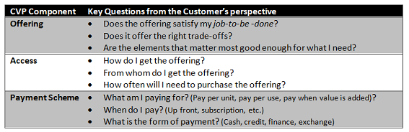
The levers below capture factors to be considered, in each case they list the extremities, although the final solution may lie somewhere between the two.

Sample product/service levers
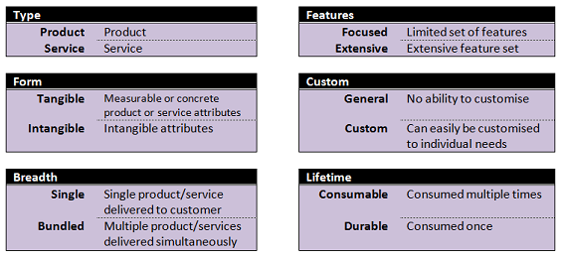

Sample access levers
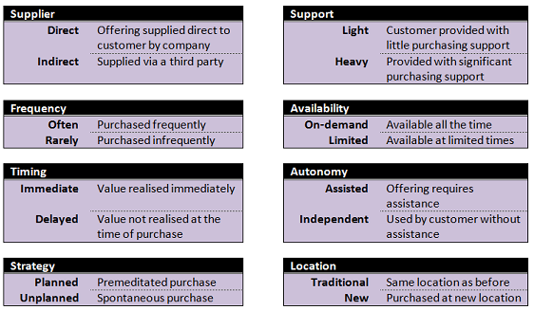

Sample payment levers
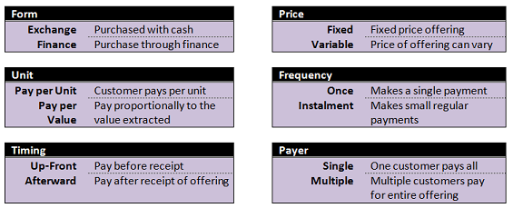

Devising Profit Formula
Recommendation is not to focus on one revenue model, instead leave a number of options open and finalise these through repeated iterations, so as not to close off opportunities too soon.

Sample Revenue Models
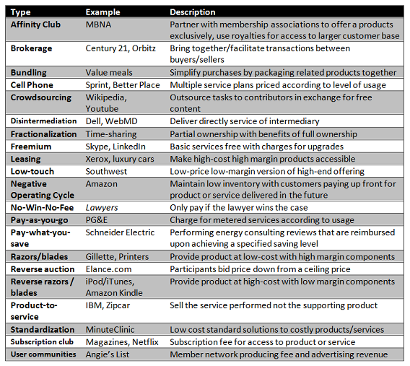

- In building the profit/loss statement create a reverse income statement without revenues, that can be used to compute the require profit (per sale) in 3 to 5 years
- Tell a story regarding how the CVP will create strong growth

- The work done in getting to this stage will have produced some key processes and resources required to fulfil the CVP. These will be tested and developed during the implementation stage that follows.
- Prior to the next phase compare the new business model with traditional elements of the business.
  - Note which items can be shared with current core competencies
  - Any potential differences between the two, which may cause conflicts

7 Implementing the Model
The model should be refined through control experimentation. Hypotheses should be tested to check whether the model will work well in practice. As key resources and processes are developed to deliver the customer value proposition.

Proposal; the model should be implemented over 3 phases
Incubation  (1-3 yrs) | Identify assumptions most critical to success and examine these.  - Validate assumptions rather than taking them as fact  - Reduce risk by checking assumptions before implementation, using a foothold market as a test-bed  - Test assumptions in a controlled environment  - Test early, test cheaply and test often to develop the business model before committing too many resources  Seek to keep this phase independent of interference from the core to allow the creativity to flow without the normal business constraints  - Seek to indentify the best customer value proposition  - Determine what will constitute success and how to measure this  - Specific Measurable Attainable Realistic Time-bound  - Keep the scale small at this stage, until the business model is finalised
Acceleration  (2-5 yrs) | With a viable business model it is time to scale up  - Knowledge is greater  - Focus less on experimentation and define repeatable processes  - Monitor and refine these processes  - Move from foothold markets to broad market adoption
Transition  (1-3 yrs) | Applies only to incumbent enterprises; can the new model be integrated into the core or should it remain independent?  Remain Separate if Consider reintegration when  - Significantly different business roles and metrics - Distinct brand and customer value proposition - It would be disruptive to the core - Lower margin product - Lower overheads - Higher resource velocity - Differentiated by resources and processes - Similar profit formula - Greater unit margins - Enhances core brand - Can transform and improve core

Buying New Business Models
When considering Merger & Acquisitions determine the current business model at play
- It is easier to bring in businesses at the incubator stage, as their process is still being refined
- Integrating into the core may break the business model
  - Consider retaining as a silo
  - Check for suitability of integration
  - Seek to allow the acquired firm to extract value from the core

8 Overcoming Incumbent Challenges
- Where core processes are well ingrained alterative offerings may be rejected prematurely
- The tendency to tie a new opportunity to the existing business model can be catastrophic
  - Remember that it is supporting a new customer value proposition
- Business innovations often come second place to core solutions, resulting in resources issues
  - There may be concerns regarding cannibalization
  - Pressure exists to break the innovation out of incubation too soon

- The current model has generated a system of existing rules, norms and metrics which may well differ from those required by the innovation
  - Such establishments should create friction against changing successful practices
  - Devised rules may inhibit a fundamentally new customer value proposition

Core Business Model activities which interfere with new business models,
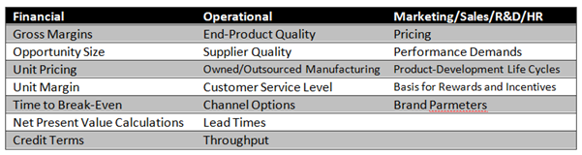

- Financial expectations are normally based around the core and can be difficult to overcome
  - With disruptive industry models being especially challenging
- Beware of seeking to leverage existing resources and process as they may hamper/break the model
  - Allow new model to borrow from appropriate the core competencies
- Ensure level of responsibility are understood, if possible release human resources from other projects
- Consider how best to implement reward scheme for projects seeking break-even in the future

In many businesses there are multiple products progressing through different stage of their product life cycle, with new concepts rising to replace those in decline

Strategy and Business Models
Harvard Business School historian Alfred Chandler argued that "structure follows strategy", but this does not automatically evolve. The resultant structure needs to be governed by the imperatives of the business model.
Claim: strategy follows structure in the typical organisation by seeking incremental improvements on the current model

Bibliography
Johnson, M. W. (2010). Seizing the White Space. Harvard Business Press.

